

Doc Query – API Documentation Explainer

Project ID: PRJ-009
Team ID: T-009
Team GitHub Repository:
https://github.com/YenugantiTarunkumar/API-Documentation-Explainer
Project link: https://api-documentation-explainer.vercel.app/

Student Name | Registration Number | Individual GitHub Link
Yenuganti Tarun Kumar | 99230040893 | https://github.com/YenugantiTarunkumar/GEN-AI-
G Mohith Reddy | 99230041073 | https://github.com/Mohith1617/Gen-ai
Marneni Venkat Nithin | 99230041229 | https://github.com/vnm19102-hub/Gen-AI-Assignments
Sammanu Hemanth | 99230040416 | https://github.com/hemanthyadav697-svg/GEN-AI-ASSIGNMENTS
Tirupati Chandra Sekhar | 99230040887 | https://github.com/Chandrarajutirupati/GEN-AI-Assignment

Project Trainer / Guide
Mr. SHIRWIN PRINCE I

Table of Contents

- Introduction Section 1

- Problem Statement & Objectives Section 2
- System Architecture (RAG Pipeline) Section 3

- Implementation Details & Tech Stack Section 4
- Results and Testing Section 5

- Conclusion & Future Scope Section 6

Introduction
DocQuery is an API Documentation Explainer that helps developers understand and query OpenAPI specifications through natural-language questions. Instead of manually searching lengthy API documentation, users can ingest an API specification or upload a supported document and ask questions about endpoints, parameters, request fields, responses, and multi-step API workflows.
The application combines document/specification ingestion, keyword-based retrieval, anLLM-powered answer generation layer, source references, and a confidence-aware agent workflow. Its retrieval pipeline is designed to ground responses in the indexed material and show the relevant endpoint or document chunk so users can verify the answer.

Problem Statement & Objectives
Problem statement: API documentation can be lengthy and difficult to navigate. Developers may need to locate specific endpoints, understand required parameters, inspect request/response schemas, or determine the sequence of operations for a task. Conventional keyword search can miss relevant information when a question uses different wording from the specification.
Objectives:
- Provide a conversational interface for asking questions about API documentation.
- Accept OpenAPI specifications from a URL or JSON file, and support PDF/TXT document uploads.
- Resolve schema references and prepare searchable endpoint/document chunks.
- Retrieve relevant evidence using BM25 keyword ranking and present source references with answers.
- Support multi-step questions, follow-up questions, and queries across multiple indexed specifications.
- Offer selectable LLM providers and a lightweight confidence score to help users assess grounding.

System Architecture (RAG Pipeline)
The DocQuery system is designed to help users understand API documentation by asking questions in simple English.
The system works in two main phases:
- Data Ingestion Phase – Preparing and storing the documentation.
- Query and Generation Phase – Finding relevant information and generating answers.
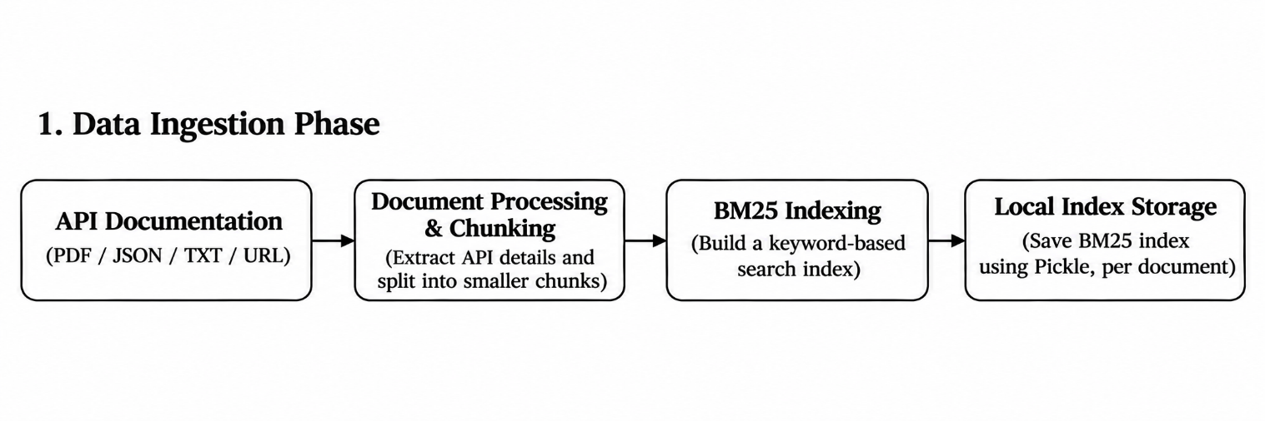
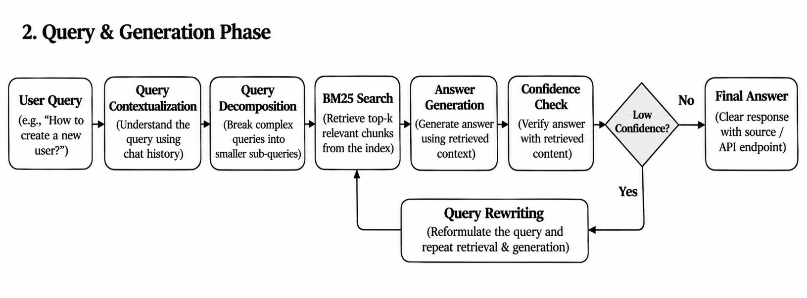
3.1 Data Ingestion Phase

This phase prepares the documents before users start asking questions.
Step 1: Document Input
The user provides API documentation through a URL or uploads a JSON, PDF, or TXT file.
For API specifications, the system reads information about endpoints, parameters, request bodies, and responses.
Technology used: Python, FastAPI, HTTPX, PyMuPDF.

Step 2: Document Processing and Chunking
The system extracts useful information from the documents and divides it into smaller sections called chunks.
For API documentation, each chunk contains information about a particular endpoint or its details. This makes it easier to find relevant information later.
Technology used: Python and custom document-processing functions.

Step 3: Indexing the Information
The processed chunks are prepared for searching. The system uses BM25, a keyword-based search method, to identify which chunks are most relevant to a question.
The prepared index is saved locally so that the system does not need to process the entire document again for every question.
Library used: rank-bm25
Storage: Local BM25 index files using Python's pickle module.

3.2 Query and Generation Phase

This phase begins when the user asks a question.
Step 1: User Query
The user enters a question, such as:
"Which API endpoint is used to create a new user?"
The frontend sends the question to the backend.
Technology used: React and FastAPI.

Step 2: Query Contextualization
The system checks whether the current question depends on an earlier conversation. It uses recent chat history to understand follow-up questions and converts them into meaningful standalone questions.
For example, if the user asks "What parameters does it require?", the system uses the previous conversation to understand which API endpoint the user is referring to.

Step 3: Query Decomposition and Specification Routing
If the user asks a complex question involving multiple operations, the system divides it into smaller questions.
The system separates the guery into individual tasks so that relevant information can be retrieved for each step.
When multiple API specifications are available, the system can also identify which documents are relevant to the question.
Technology used: LangGraph and LLM-based query processing.

Step 4: Information Retrieval
The BM25 search system compares the processed questions with the stored documentation chunks and selects the most relevant information.
For complex questions, it retrieves information for each smaller task and combines the results.
The system also prioritizes relevant endpoint information and balances the retrieved content before sending it to the language model.
Library used: rank-bm25

Step 5: Answer Generation
The retrieved information is sent to the selected Large Language Model (LLM).
The model uses the user's question and the retrieved documentation to generate a clear and understandable answer.
The system supports multiple LLM providers:
- Groq – GPT-OSS 120B
- Google Gemini – Flash
- Hugging Face – Llama 3.1
Technology used: LangGraph and provider-specific LLM integrations.

Step 6: Confidence Checking and Query Rewriting
After generating an answer, the system calculates a confidence score by comparing the answer with the retrieved documentation. It also checks whether JSON examples contain fields supported by the documentation.
If the confidence score is below the required threshold, the system attempts one corrective step. Depending on the question, it can regenerate the answer using the existing retrieved information or rewrite the query and perform retrieval again.
The system then selects the better-supported answer.
Technology used: Custom confidence-scoring functions and LangGraph.

Step 7: Final Answer and Source Display
The final answer is displayed to the user along with source information, such as the API endpoint or document section from which the information was retrieved.
This helps users understand where the answer came from.
Technology used: React and FastAPI.

3.3 Workflow Management and Monitoring

LangGraph – Workflow Management
LangGraph manages the complete question-answering process. It controls the movement between query processing, retrieval, answer generation, confidence checking, and corrective steps.

Langfuse – Monitoring
Langfuse is used to monitor the system's execution. It helps track user queries, retrieved information, LLM calls, generated answers, and confidence scores. This makes it easier to observe and evaluate the system's performance.

Implementation Details & Tech Stack

Component | Technology Used | Purpose
Frontend | React 19, JavaScript, Vite | Provides the user interface for uploading documents, asking questions, and viewing answers.
Backend | Python 3.11+, FastAPI, Uvicorn | Handles document processing, user queries, retrieval, and answer generation.
Document Processing | Python, HTTPX, PyMuPDF | Fetches API specifications from URLs and extracts information from JSON, PDF, and TXT files.
Orchestration Framework | LangGraph | Manages the workflow of query processing, retrieval, answer generation, confidence checking, and correction.
Information Retrieval | BM25 (rank-bm25) | Searches the indexed documentation using keywords and retrieves relevant information.
Index Storage | Python Pickle, Local Files | Saves BM25 indexes locally for reuse without processing documents again.
Large Language Model | Groq (GPT-OSS 120B) | Generates answers using the retrieved documentation.
Additional LLM Providers | Google Gemini Flash, Hugging Face Llama 3.1 8B | Provides alternative models for generating answers.
Confidence Scoring | Custom Python Functions | Checks how closely the generated answer matches the retrieved information.
Observability | Langfuse | Tracks retrieval, LLM generation, and confidence-related information for monitoring and debugging.

Results and Testing

The DocQuery system was tested using API documentation in PDF and JSON formats.
- Swagger Petstore OpenAPI Specification: A publicly available API specification used to test ingestion and retrieval of API endpoints, parameters, authentication details, and response codes.
- API Documentation Test Samples: A six-page synthetic document containing two sample APIs: a User Management API and an E-commerce Orders API. It was used to test endpoint retrieval, request and response details, authentication methods, error codes, rate limits, and questions requiring information from both documents.
These documents were used to evaluate document ingestion, retrieval relevance, context-based answer generation, and multi-document question answering. The sample APIs are for testing purposes and do not represent live services.

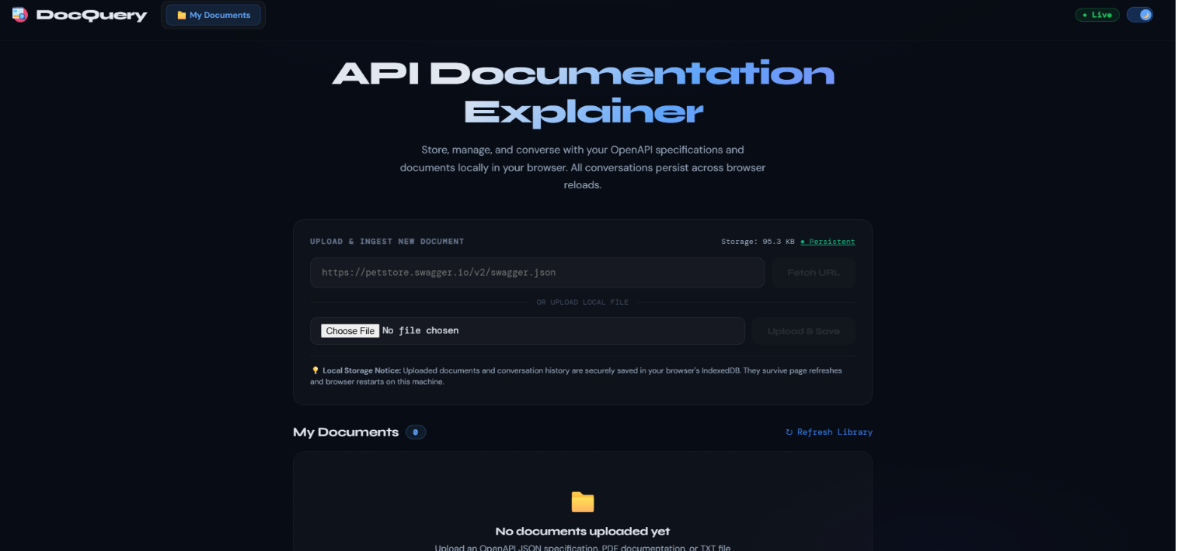

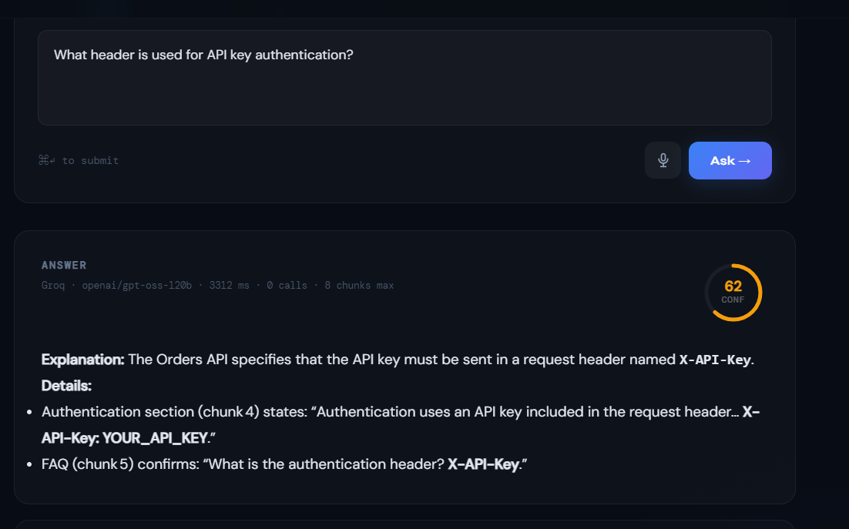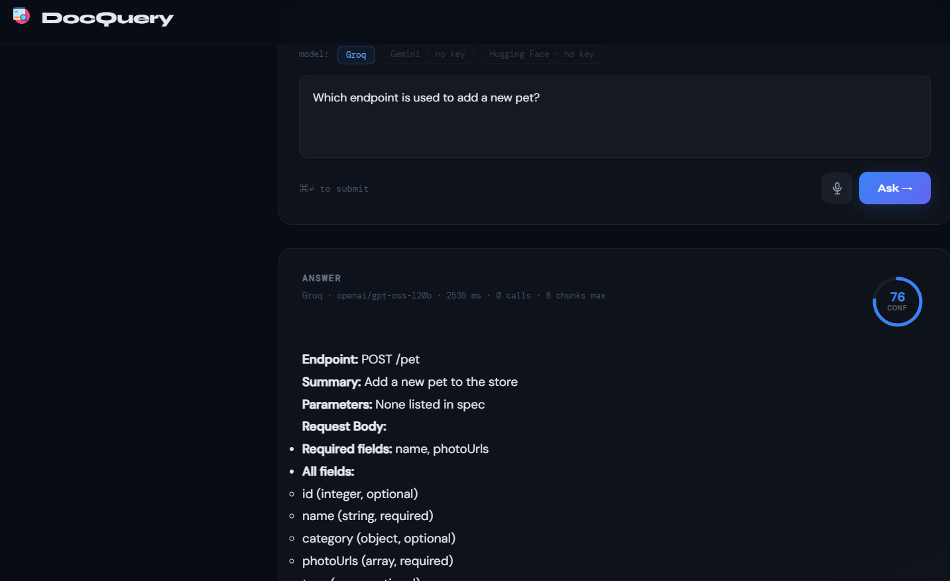

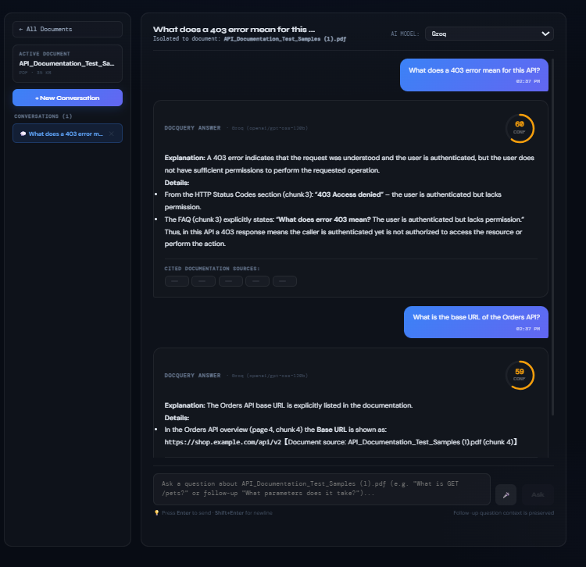

Conclusion & Future Scope
Conclusion
DocQuery is a document-based question-answering system designed to help users understand API documentation more easily. It uses document processing, information retrieval, and language models to find relevant information and generate answers based on the uploaded documents.
The system was tested using API documentation in PDF and JSON formats, including the Swagger Petstore specification and sample User Management and E-commerce Orders APIs. These tests helped evaluate document ingestion, information retrieval, and question answering across documents.
The project demonstrates how Retrieval-Augmented Generation (RAG) can make technical documentation easier to access and understand. Instead of manually searching through lengthy documents, users can ask questions in natural language and receive relevant answers. Future improvements can make the system more accurate, scalable, and useful for different types of technical documents.

Future Scope
In the future, DocQuery can be enhanced to support more document formats and larger files. Semantic search and improved retrieval techniques can be added to provide more accurate answers. The system can also include API testing features, document management, and support for technical manuals and other types of documents.

